myLaw Documentation for Student Groups

On myLaw every group has an area all of its own. From this area you can create pages of content, post announcements and discussion topics, browse through the files you have posted, assign a logo to your posts, manage membership to your group, and set permissions.

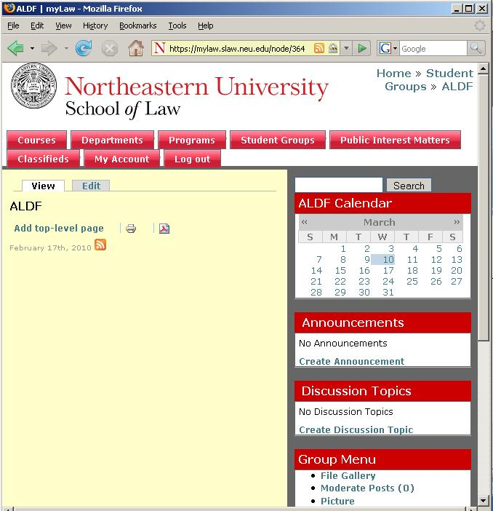

**Static pages**

There are three different kinds of static pages that we will be talking about. The group page, top level pages, and child pages.

Group Page

The group page is the first page that someone will see when they go to your group. If you are an admin for the group, you can edit the group page by clicking the “Edit” tab at the top of the screen. From this screen you can also edit the way that your group’s name appears.

Top Level Page

A top level page is a page which creates an entry into the table of contents for your group. From the group page you can add a top level page from the link at the bottom of the page saying “Add Top Level Page”. There are a few more options included in the Top Level Page including “Group Privacy” and “Book outline”.

*Group Privacy*

By clicking on the “Group Privacy” link you will extend more options. It will contain an option called “Select your group privacy level”. This will determine who, inside or outside your group, will be allowed to view the page that you have created. The options are: Admin, Members, Community, and Public.

*Book Outline*

By clicking on the “Book outline” link you will extend more options for how the table of contents is structured. Most of the time you will use the defaults, and not want to alter these settings. If you ever make a mistake and wish to change where a page is in the table of contents you can alter the “Book” and “Parent item” settings so that the page falls under the right place. The “Book” refers to the Top Level Page where the page should be located under. The “Parent item” refers to the page that the page you are editing should fall directly under.

By default the table of contents will list everything in alphabetical order. Sometimes you will want to have more control over how items are listed. In this case there is the “Weight” option. The higher the weight is set, the lower it sinks to the bottom. If two or more pages have the same weight they will be listed in alphabetical order. The weight can range anywhere from -15 to 15.

Child Page

A child page is a page which will show up in the table of contents underneath a Top Level Page or another Child Page. A link to add the child page will show up at the bottom of a Top Level Page or Child Page saying “Add Child Page”.

*File Attachments*

You also have the option of attaching files to any of the pages, as well as announcements and discussion topics. By clicking on the link “File attachments”, you will expand this area to show more options. To attach a file click the “Browse” button. This will allow you to search your computer for the file you wish to upload. After selecting your file, click the “Attach” button to add the file. The file will now appear with an address below it showing the location of the file. This is useful if you wish to link to the file from an outside source, or when inserting an image into your post. To the left of the file will be two check boxes. The first allows you to delete the file, if you choose to replace it at a later time, the second determines whether the file will be listed at the bottom of the post. This will display it similarly to an email attachment.

When you attach a file to a post, it will be listed in your group’s file gallery. You can access the file gallery from the “Group Menu” located on the right.

If you wish to attach a file that you have already uploaded through another post, you can do so by expanding the “Attach from file gallery” section and selecting the file(s) you wish to attach.

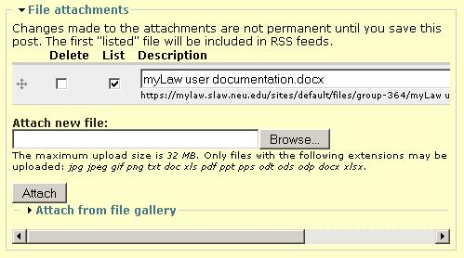

**Announcements**

Announcements are used for communication from one group to another. Most commonly the groups you will be sending announcements to will be the Class Years, or All Community.

To create an announcement click on the “Create Announcement” link located within the “Announcements” box on the right.

*Audience*

The first field you will be entering is the Audience field. This is where you select who the announcement is going to. If you select any audience which has a “*” after the name, your message will be moderated before it is published. If you wish to select multiple groups, hold the CTRL key on PC’s or the command key on a MAC.

*Standard Fields*

The next field is the title of your announcement. Following that is the teaser which is a short summary of your announcement. Please limit this to 3-5 lines. Next is the body, which contains the bulk of the information for your post.

*Calendar Event*

The next section is for the “Calendar Event”. Click on the title to expand your options in this section. By checking off the “Create Calendar Event” checkbox you will create a calendar entry for your announcement for the date and times specified below it. You also have the option of creating repeating events. Expand the “Repeat Dates” section. By clicking on days of the week you will create a series of announcements with calendar entries on the days specified until the “Repeat Until” date. “Repeat # of weeks” refers to the number of weeks that will go by before creating the next announcement. So a value of 1 will be every week, a value of 2 will be every 2 weeks, and a value of 4 would be every month.

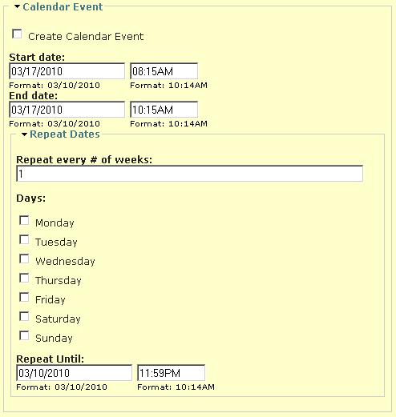

*Public Interest*

By expanding the “Public Interest” section, you will see a checkbox for “Public Interest Post”. By checking this box you will first make your announcement viewable to everyone, including the general public. Secondly it will be posted in the “Public Interest Matters” area of myLaw.

*Scheduling options*

Scheduling options allow you to specify when the announcement will be published, and when it should expire.

*File attachments*

This is the same mechanism as used by the static pages described above.

*Comment Settings*

Announcements have the ability to let people comment on them. By default this option is set to “Disabled” as most of the time, comments are not wanted. The “Read only” option allows the creators of the announcement to post comments, but the readers cannot. The “Read/Write” option would be the most likely option to choose as it allows readers to write comments, and read the comments of others. The “Write only” option is so that readers can write comments, but only the creators of the announcement can read them. This allows the comments to be moderated before they are read.

**Discussion Topics**

While announcements are for communication between groups, discussion topics are for communication from individuals to groups. The audience will determine what groups will be a part of the discussion. For departments, all members of the community can view the discussions, while for others it will depend on their permission settings, which will be discussed later. The other fields for the discussion topic include the basics from the announcement: Title, Teaser, Body, File Attachments.

**Picture**

Each group can have an icon which can be associated with their posts. This can be set from the “Picture” link in the “Group Menu” on the right. From there you will be presented with a field to upload your picture. There are some issues with Internet Explorer when using this functionality, so it is best to use Firefox.

**Membership Requests**

Groups can set how people can become members of their group. This can be set from the “Membership Requests” link in the “Group Menu” on the right. There are four options for accepting members: Open, Moderated, Invite only, and closed. When membership is “Open” anyone can join the group by clicking on a “Join” link that will appear on the Group Page. When membership is “Moderated” someone would have to click the “Join” link, and then an administrator for the group would have to approve each request. When membership is “Invite only” or “Closed”, there is no “Join” link, and all members have to be manually entered.

**Membership**

Group membership is managed from the “Membership” link in the “Group Menu” on the right. When you click on the link you will see a page such as below: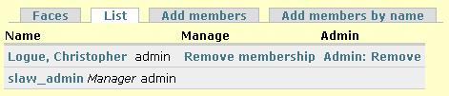

The “Faces” tab will show you a view of all the members in the group showing the individual’s picture if applicable. This view is nice to look at, but does not have the features of the “List” view.

The “List” tab will show all the members in the group, along with some valuable information, such as whether they are an administrator, the ability to remove a member, and the ability to make a member an admin.

The “Add members” tab is a form which allows you to add multiple members to your group at once. The catch with this tab is that you can only enter members by listing their NUID number. To compensate for this we created the “Add members by name” tab.

The “Add members by name” tab is a form which allows you to add one member at a time to your group from a dropdown box containing all the names of members of the law school. After selecting the name you wish to add click “add user” to add that person as a member of your group.

**Permissions**

We gave each group the ability to set their own permission structure. While this is a little bit complicated, it also gives each group a lot of flexibility as to how they wish their group page to be run. If you need help determining how you wish to set your permissions, please contact us at x8919 or [slaw_ocs@neu.edu](mailto:slaw_ocs@neu.edu).

Each permission can be one of five values: Admin, Member, Community, Public, Disabled. A person’s access level within the group will determine whether or not they are allowed to perform a permission’s action. Below are the default permissions for a Student Group:

|  |  |  |  |  |  |  |
| --- | --- | --- | --- | --- | --- | --- |
| **announcement module** | | | | | | |
| create announcement |  |  |  |  |  |  |
| edit own announcement |  |  |  |  |  |  |
| view announcement |  |  |  |  |  |  |
| **comment module** | | | | | | |
| administer comments |  |  |  |  |  |  |
| **og_book module** | | | | | | |
| add content to books |  |  |  |  |  |  |
| administer book outlines |  |  |  |  |  |  |
| view books |  |  |  |  |  |  |
| **og_delivery module** | | | | | | |
| create group to group posts |  |  |  |  |  |  |
| create user to group posts |  |  |  |  |  |  |
| moderate group to group posts |  |  |  |  |  |  |
| moderate user to group posts |  |  |  |  |  |  |
| view posts to group |  |  |  |  |  |  |

As we go down the list, the permissions get more obscure and hard to understand.

Announcement permissions are self explanatory. The “create announcement” permission allows you to create an announcement. In the case of the default, only admins can create an announcement. Likewise by default only members of a group can view announcements that have the group as an audience.

Comment permissions are also self explanatory. By default admins for a group can administer comments: Delete, publish, unpublish.

Og_book module is a little bit confusing because of the name. In the system a “book” is a “Top Level Page”. So the permission “add content to books” it is referring to the ability to add a “Top Level Page” and “Child Page”. It is important to note that by default the “view books” permission is set to “Public” allowing anyone to see the content unless you change the permission, or set the “Group Privacy” for a page.

Og_delivery module is the most confusing of the permission sets. If you are unsure of what to set here, either leave it alone, or contact someone from computer services for assistance. The og_delivery module controls the audience functionality of the site.

The first setting is “create group to group posts”. This pertains to announcements. If you remember earlier, announcements are for communication from one group to another group. If you change who is allowed to create an announcement, you will also want to change who can create a group to group post. Otherwise you will only be able to create announcements to members of your own group.

The next setting is “create user to group posts”. This pertains to discussion topics. If you remember earlier, discussion topics are for communication from an individual to a group. If you change who is allowed to create a discussion topic, you will also want to change who can create a user to group post.

The next setting is “moderate group to group posts”. This again pertains to announcements. By default this setting is set to “Admin”, which means when another student group wishes to post an announcement with your group in the audience field, they will need permission from an admin for the post to be read. Keep in mind that departments and student programs are exempt from needing permission.

The “moderate user to group posts” is similar to the last setting, only it pertains to discussion topics. By default this is set to “Disabled”, which means that there is no moderation required for someone to post a discussion topic.

The “view posts to group” is self explanatory. If you choose to change the “view announcement” permission, you would probably want to change this one as well. By default it is set so that all members can view posts sent to the group.

**Moderation**

Lastly, there is the moderation page. To access the moderation page click on the “Moderate Posts” link in the “Group Menu” box on the right. Note that the number next to the “Moderate Posts” link will indicate the number of posts needing moderation. If you have any posts needing moderation, it will show a list of the posts. Next to each most there will be radio buttons asking you if you wish to “accept”, “delete”, or “do nothing”. After selecting a radio button, be sure to submit the form to apply all changes. By accepting a post it will be published to members of your group.